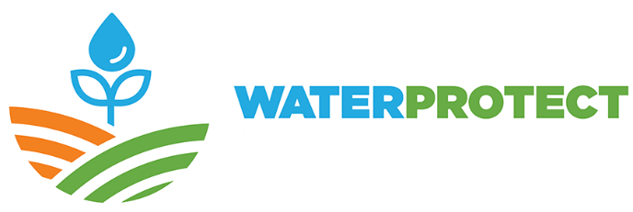

D6.3 Identification of key end-users that can upscale the WaterProtect roadmap

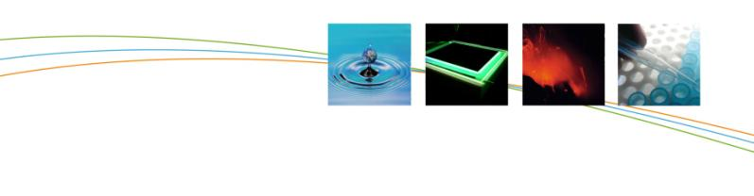

CHANGE RECORD
Version | Date | Description
1.0 | 25/01/2019 | Initial version
2.0 | 31/01/2019 | Worked comments from Paul Campling and Ingeborg Joris included
3.0

Colofon

Organisation:
WaterProtect

Date:
January 25th, 2019

Website:
www.water-protect.eu

Version 2.0
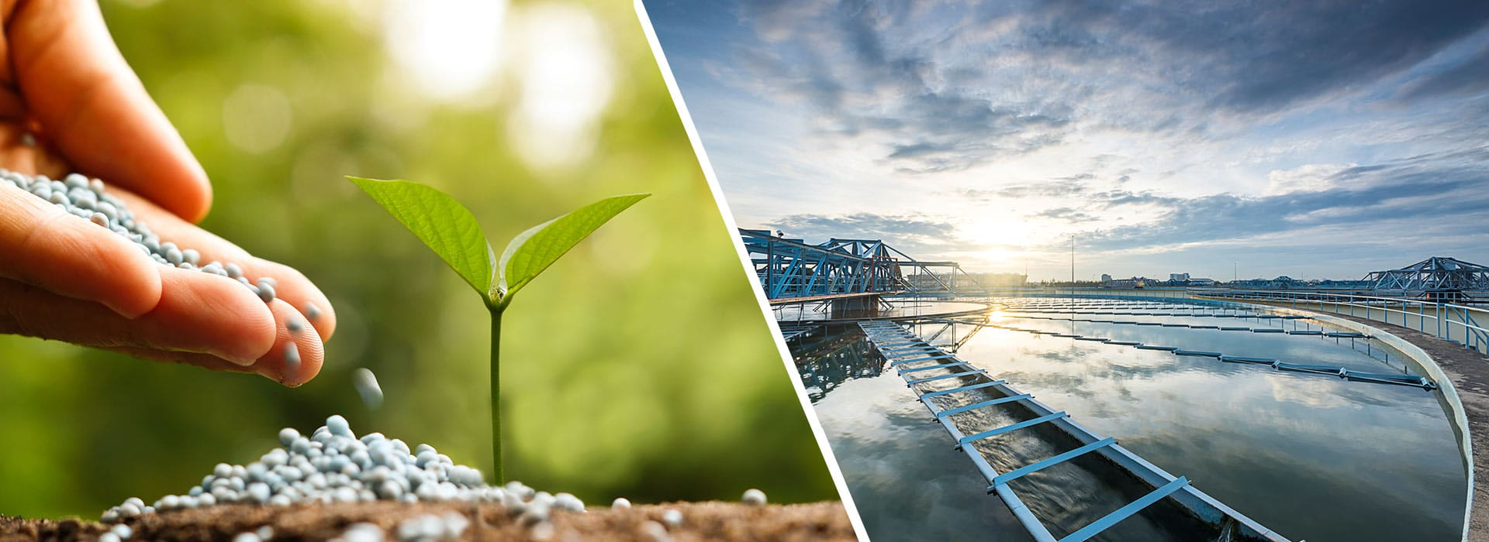
This contribution was created thanks to the contribution of WP6 partners:
- VLAAMSE INSTELLING VOOR TECHNOLOGISCH ONDERZOEK N.V. (VITO)

- INAGRO, VZW (INAGRO),

- EIGEN VERMOGEN VAN HET INSTITUUT VOOR LANDBOUW EN
VISSERIJONDERZOEK (EV ILVO),

- AGRICULTURE AND FOOD DEVELOPMENT AUTHORITY (TEAGASC),

- GEOLOGICAL SURVEY OF DENMARK AND GREENLAND (GEUS),

- UNIVERSITA CATTOLICA DEL SACRO CUORE (UCSC),

- AGENCIA ESTATAL CONSEJO SUPERIOR DEINVESTIGACIONES CIENTIFICAS (CSIC),

- PANSTWOWY INSTYTUT GEOLOGICZNY - PANSTWOWY INSTYTUT BADAWCZY (PIC-PIB),

- KOBENHAVNS UNIVERSITET (UCPH),

- ASOCIATIA ECOLOGIC BAIA MARE (ECL),

- EUROPEAN FEDERATION OF BOTTLED WATERS (EFBW),

- THE EUROPEAN WATER PARTNERSHIP AISBL (EWP).

January 25th, 2019
T. Vereijken, rapporteur

Contents

COLOFON - 3 -
Contents - 5 -
Introduction - 6 -
Who are key end-users? - 7 -
- 9 -

Introduction

High-quality, safe, and sufficient drinking water is essential for life: we use it for drinking, food preparation and cleaning. Agriculture is the biggest source of pesticides and nitrates pollution in the fresh waters of Europe.
The overarching objective of WATERPROTECT is to contribute to effective uptake and realisation of management practices and mitigation measures to protect drinking water resources. Therefore, WATERPROTECT is creating an integrative multi-actor participatory framework that includes innovative instruments to enable actors to monitor, to finance and to effectively implement management practices and measures for the protection of water sources.
In close cooperation with actors in the field, at local and EU level, WATERPROTECT is developing innovative water governance models that investigate alternative pathways focusing on the ‘costs of water treatment’ to ‘rewarding good water quality delivering farming systems’. Water governance structures are built upon cost-efficiency analysis related to mitigation and cost-benefit analysis for society and is supported by spatially explicit GIS analyses and predictive models that account for temporal and spatial scaling issues. The outcome is improved participatory methods and public policy instruments to protect drinking water resources.
WATERPROTECT Work package 6: Upscaling to EU
Upscaling the results and outputs of the WaterProtect project to European level is an important component of overall aim to exploit solutions identified beyond the seven Action Labs. In order to facilitate this, the information needs to be applicable and communicable to potential end users at the regional level. This work package starts by setting the stage and exploring the playing field in terms of how stakeholders in Europe are adapting farming systems to ensure sustainable water management. Linking WaterProtect results to other best examples and using that information in the broader communication and dissemination of the project, will cause the project to have greater impact.
A comparison of the results and the process in the different case studies has been presented in D6.1: ‘Complete comparative case study assessment’ (June 29th, 2018) which provides insights into governance strategies that work, and can help improve water quality in other EU regions. The project wants to upscale the lessons learned to other areas of Europe via a blend of direct knowledge share through participatory and facilitated workshops and more broad information dissemination targeting relevant/interested stakeholders as key end-users, who need to be identified.
The identification of these key end-users is goal of this deliverable (D6.3), which is not so simple as it seems. In the end, we are all end-users of the water we need. Nevertheless, in the frame of upscaling WaterProtect research results, this deliverable will help identifying the most influential and relevant stakeholders that can upscale the WaterProtect roadmap (D6.4).

Who are the key end-users?

The Water Framework Directive in 2000 was the start of a huge legislative programme to improve Europe’s surface water qualities. We went from being used to see ‘black water’ in rivers to the current state, where water quality is usually good and society increasingly even wonders how to further improve the ecological status of Europe’s waters.
Agriculture, as one of the main users of sweet water has a vested interest in water availability and good water quality, and is generally much aware of its main influence on the future quality of water. Farmers have a huge ‘control panel’ of variables at hand, to influence water related issues in their daily work in support of biodiversity and water quality.
The farmer’s paradigm
Water is just a minor factor in all the daily matters a farmer has to deal with. His income depends on many uncertain factors, of which the availability of water is just one. The future water quality is probably even much less of his concern in the day to day decisions he takes in his work. Especially when it concerns groundwater - invisible and not very well understood – there is no urgency.
A wicked problem
Yet, it is obvious that the effects of what farmers do (or don’t) on water quality can have a very significant impact on the many parties in the food and water chains. Therefore, the management of water quality in agriculture is a so-called ‘wicked problem’: one party makes the decisions, has a major influence but is not compensated to do the right thing, yet many other parties are depending on his or her decisions taken and the (irreversible) effects of it.
Society is beginning to comprehend the major importance of sustainable farming. Moreover, people are grasping that non-sustainable agricultural activities are often also irreversible, hence damaging our future. Farmers are experiencing this as a social pressure. Often farmers are very much willing to comply with sustainability principles, as much as reasonably possible. But here is an important issue: in the current price and volume-driven market conditions, crucial elements are missing for the farmer to do the right things in his work, such as:
- the compensation for his additional efforts
- the education of what sustainable practices are
- the cooperation with other parties in the chain
- recognition for his dedication.

Key end-users
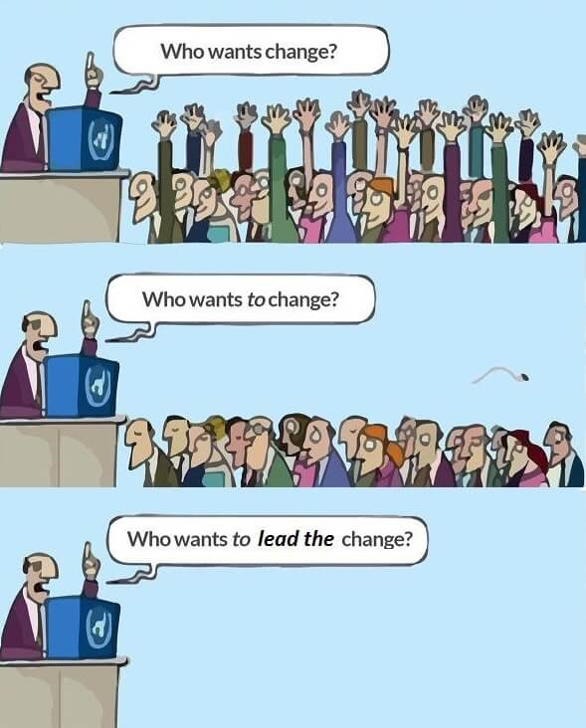
Therefore, to get upscaling effects more quickly, key end-users of WaterProtect research results are probably not only the farmers, but the key end-users group needed to include the farmer’s chain partners who could offer to fill in these and other elements currently missing to quickly build a better business model for the farmer and a more sustainable agricultural sector.
We have two types of key end-users:
- ‘bottom-up’ key end-users: grass root initiatives, local scale, many of which are like the case studies described in D6.1 . These are the so-called ‘Best Practice Measures Users’ and benefitting organisations communicating the positive effects of BPMs and EWS schemes like:
  - the Skylark Foundation (https://veldleeuwerik.nl/en/ ),
  - ‘Boer Bewust’ Initiative (https://www.boer-bewust.nl/),
  - Capwasa (https://www.ewp.eu/collective-action-partnerships-in-agr )
  - Dairyland Stewardship Council (‘Land van Waarde’ https://www.courage2025.nl/projecten/kringloop-zonder-grond )
- ‘top-down’ key end-users: at many different levels (EU networks, national networks, industrial federations, SDG networks, supermarkets, consumer organisations). Examples are:
  - European Partners for the Environment (EPE, www.epe.be)
  - Asvis (http://asvis.it/asvis-italian-alliance-for-sustainable-development)
  - Coop Italy (https://www.e-coop.it/web/guest?antiCache=1549034459031)
  - Eticae – Stewardship in Action (http://www.eticae.it/)
  - Others like Biodiversity International, IBM food trust and TE-food, IIED, Conservation International, Finance Watch, University of Sorbonne, Just Transition Program, RFI, Caritas Internationalis, SGD Watch, V4SDG, etc.
Both groups together form the value-chain from which, the additional elements currently missing for the farmer, should be derived. Their cooperation is therefore important, and could be organised for instance to maximise the upscaling effects of Waterprotect research results.
How to put this in practice, will be the central topic of D6.4: The Roadmap for upscaling WaterProtect research results in Europe.
Two examples to illustrate what can happen if the two groups are indeed connected:
- the Best Management Practices (BMPs) that WaterProtect is developing, clearly involves the farmer is directly. WaterProtect could try and convince farmers to use them, but the range of influence is limited to pioneer farmers willing to structurally adopt the use of BMPs. You will get his long term interest more easily when public pressure translates into better prices from food processors and other compensation schemes that are required to compensate him.

- In Europe, SDG networks are currently developing rather quickly out of established NGOs. Previously working individually on separate targets, in view of the SDGs a growing critial mass is now able to attrack the serious attention of sustainable (often private) financiers gathering to bring adequate funds towards the realisation of the SDGs. These top-down end-users, - when involved - will have the purchasing power to change things at the farm level.
Upscaling WaterProtect results into the European Union will accelerate if the involvement of chain partners can be organised. If new initiatives trying to implement the new business models for farmers are involved. If educational organisations are involved to secure the ‘future pioneer farmer’ is aware and trained to manage water quality and to be compensated for these efforts.
As such, WaterProtect should maintain focus on the farmer, as key end-user for the upscaling of research results, but should also focus on top down chain partners, for instance the ones already demonstrating or piloting new business models for farmers. Some of them have been well described in the case studies analysed before. Besides, the ultimate key end-user (the consumer) should be actively involved. They have purchasing power to accelerate the implementation of compensating measures, and set the new ‘normal’. Finally, the unusual forms of cooperation in the frame of the SDGs will unlock interesting potential.
Regions
In the 7 Action Labs of WaterProtect, the regional success factors and bottlenecks are very different. Participatory workshops have shown this, and these factors will need to be addressed in the Roadmap for upscaling the Waterprotect results. In Eastern Europe for instance, coalitions at the bottom up levels are uncommon. Time should allow trust to develop and successful cases to be disseminated. In Southern Europe, the value of water (availability) is much developed, and we can build on this to accelerate the uptake of BMPs in the agricultural sector. In Northern Europe this awareness is much lower, and should be developed. Top down end-users might have a greater role here.
WaterProtect could start the upscaling by focussing on end-users in countries where Action Labs are active, which has the advantage of more known networks linked, and regional knowledge present. In addition, some countries could be considered to include where a current large impact can already be seen (for instance Germany and Netherlands). In parallel, it is advised to include an analysis step to evaluate in which countries the upscaling could be successful and feasible. To address also regional differences, upscaling regions include North EU (DK, NL, BE, IE), South EU (ES, IT), East EU (PL, RU).
